Neutron Transport Simulation

Abrie Greeff
13557343
23 March 2005
University of Stellenbosch
Computational Physics 214

Abstract

The simulation of neutron transport has been of importance the past few years in the research of neutron interactions in the fields of radiation and isotope production. This paper investigates neutron interaction for scattering simulations. I look at the transmission of neutrons through a bulk matter in the form of a plate of a certain thickness. At any point a neutron can either be captured with a certain probability or scattered with a different probability. A general algorithm is used to calculate the neutron scattering through the use of the Monte Carlo method.

The probabilities were calculated for different values to see the changes in the simulation. Physical parameters like the thickness of the plate and the mean free path of the neutron are varied to obtain a general result. The simulation was coded in Matlab® Release 14 and accompanies the paper.

Introduction

The algorithm used through out this simulation to determine how an arbitrary number of incident neutrons scatter is provided in Appendix A. The behaviour of each case for specific values of the probabilities, plate thickness and mean free path is analyzed and discussed. The first case that’s analyzed is for different probabilities and different mean path lengths with a fixed thickness for the plate. The cases are then simulated with fixed values but the relation between the scattering and capture probabilities are changed. The simulation is then done for changes in the thickness of the plate and the mean free path to see if there is a relation. These values are also plotted as 3D graphs to see the relations between the paths for different values of the probability and mean free path.

The simulations I’ve done so far have all been if the scattering is elastic. Next we need to verify the results for inelastic scattering. Again we do the same simulations as before but now we consider the cases for different losses of energy. It will be assumed that the mean free path is proportional to the energy of the neutron when working with inelastic scattering. For each case graphs will be provided to aid in the discussions of the results.

In Appendix B I provide code from the Matlab® program I wrote which is also included on the included stiffy. Please note this program has only been tested on Release 14.
Theory

The scatter probability and the capture probability are proportional to the scattering cross section and the capture cross section respectively. If the neutron is scattered we need to find its new direction as specified by the polar angle . The interest of how far the neutron moves in the x or y direction is not of importance. The value of azimuthal angle  is therefore of no importance.

If the neutrons are scattered equally in all directions, then the probability 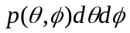 is equal to d/4 where d is an infinitesimal solid angle and 4 is the total solid angle.

Because we have

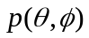 = 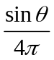

The probability density for  and  separately by integrating over the other angle. i.e.

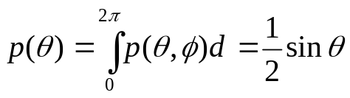

And

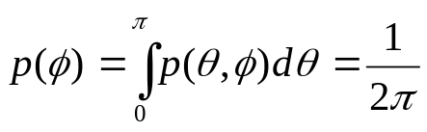

Because the point probability is the product of the probabilities 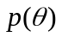 and 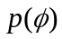,  and  are independent variables. Although we do not need to generate a random angle , we note that since is a constant,  can be found from the relation

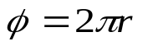

To find  according to distribution

We obtain

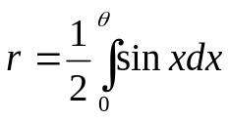
If we do integration we find: 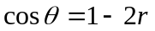
Note that implies that  is uniformly distributed between 0 and 2 and implies that 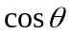 is uniformly distributed between -1 and 1.
To find the z-component of the path of the neutron through the plate we need to multiply by the path length L, and hence we need rather than  . The path length, which is the distance travelled between subsequent scattering events, is obtained from the exponential probability density, 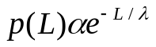.
Further we obtain 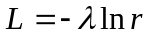, where is the mean free path.

Formalization of general algorithm

1. Determine if the neutron is captured or scattered. If it is captured, then add one to the number of captured neutrons, and go to step 5.

2. If the neutron is scattered, compute 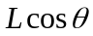 from and . Change the z-coordinate of the neutron by .

3. If z < 0, add one to the number of reflected neutrons. If z > t add one to the number of transmitted neutrons. In either case skip to step 5 below.

4. Repeat steps 1-3 until the fate of the neutron has been determined.

5. Repeat steps 1-4 with additional incident neutrons until sufficient data has been obtained.

See Appendix A for implementation of general algorithm.

Results

The first case we consider is when the thickness of the plate equals 1 and the capture probability 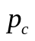is half of the scatter probability 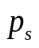. The amount of reflected, transmitted and captured neutrons is considered for different mean path lengths and probabilities. The next few figures try to show these relations. It’s first shown in Figure 1-5 for 100 incident neutrons and then in Figure 6-10 for 1000 incident neutrons. For information about how the program works refer to Appendix B.

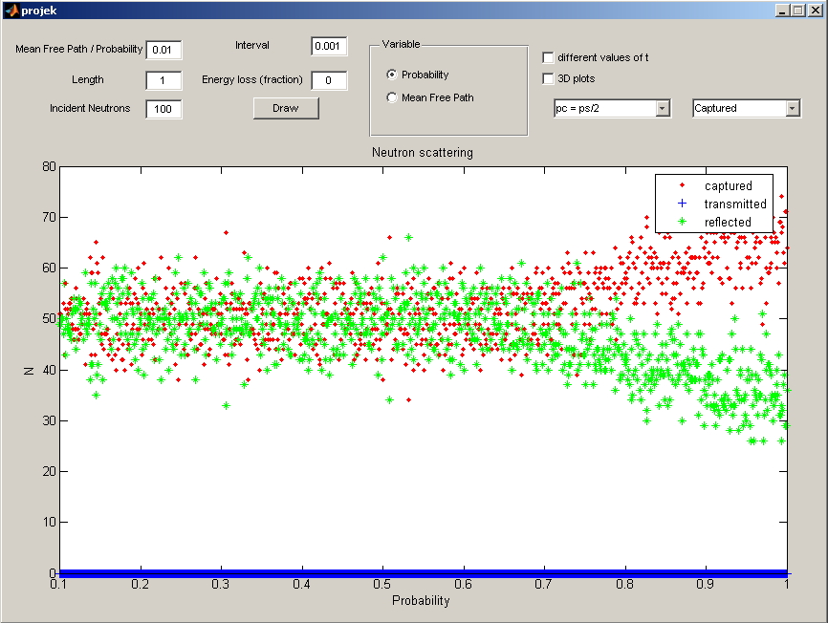
Figure 1

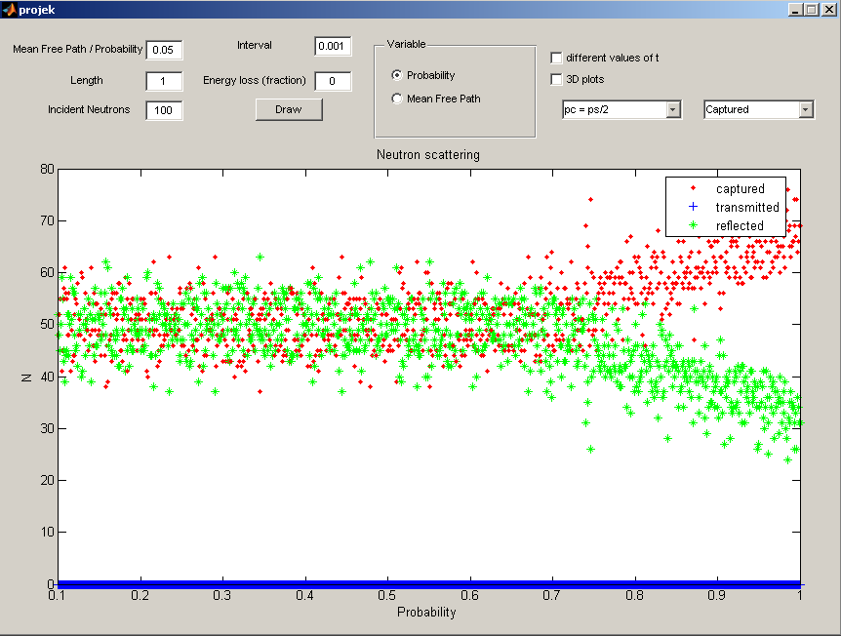
Figure 2

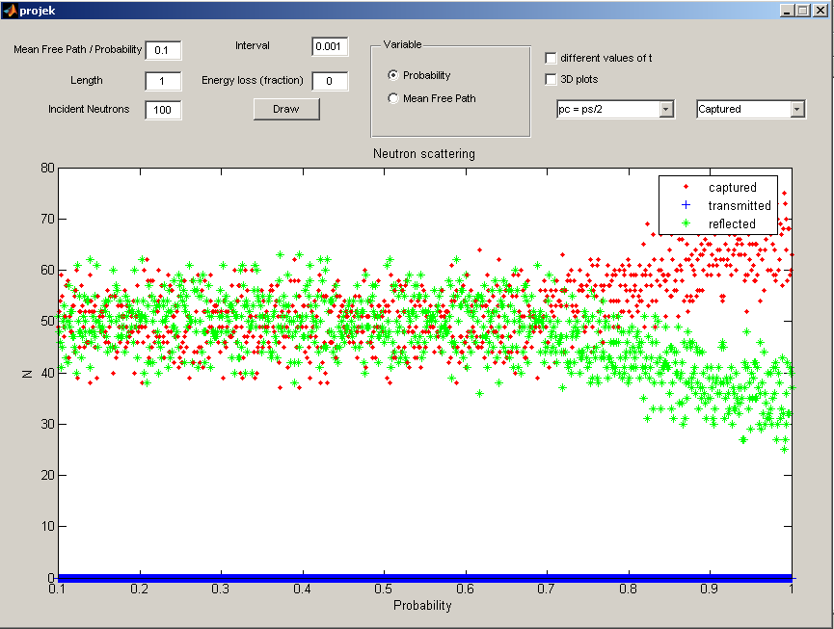 Figure 3
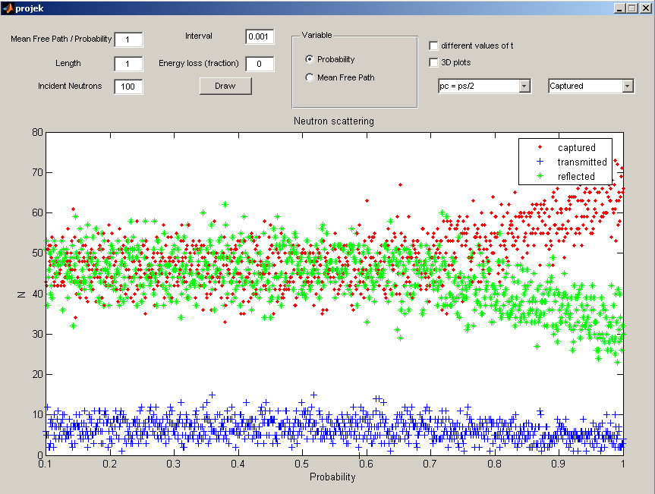 Figure 4

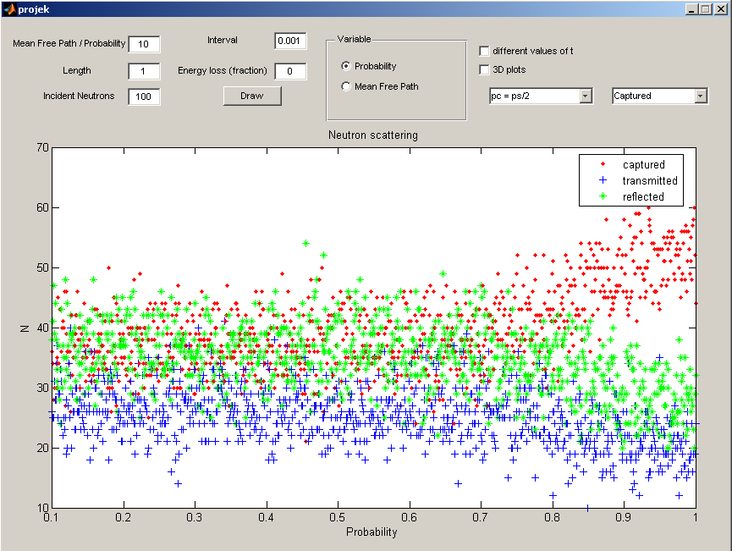 Figure 5

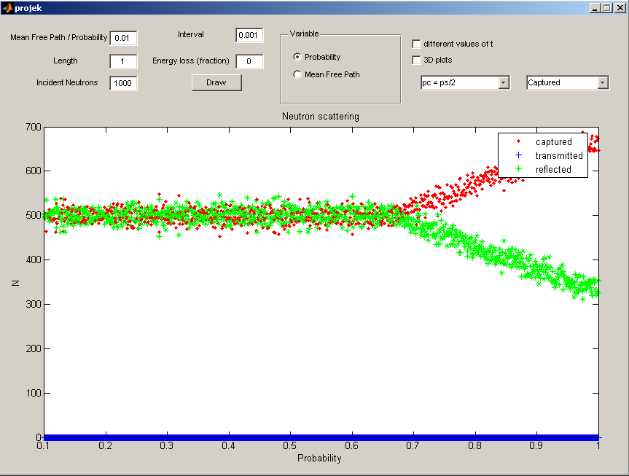 Figure 6
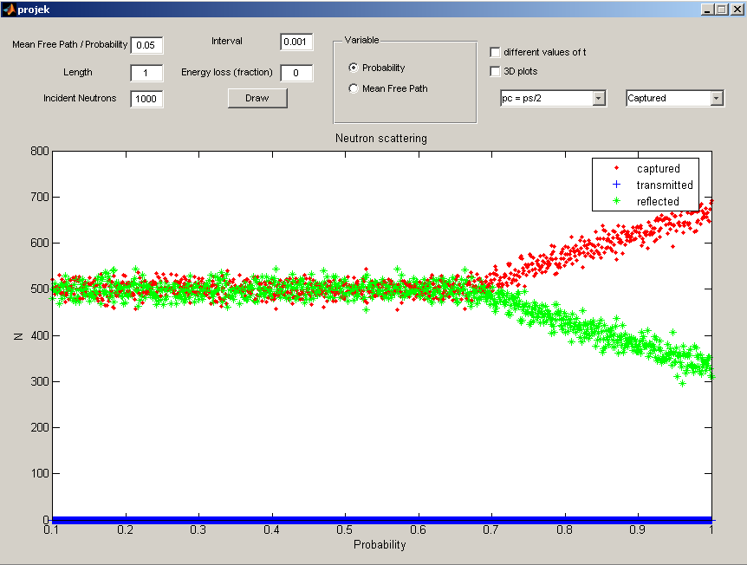 Figure 7

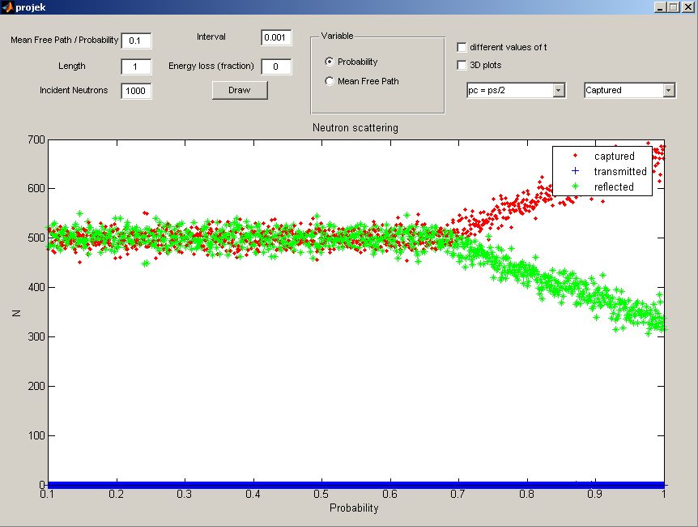 Figure 8
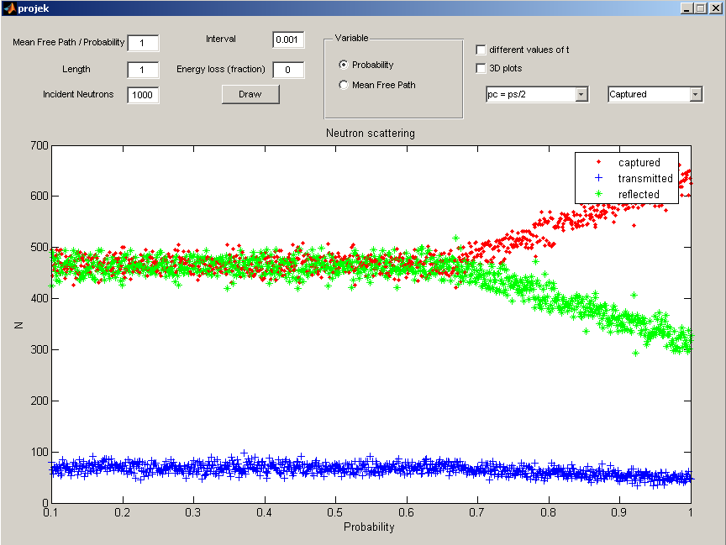 Figure 9

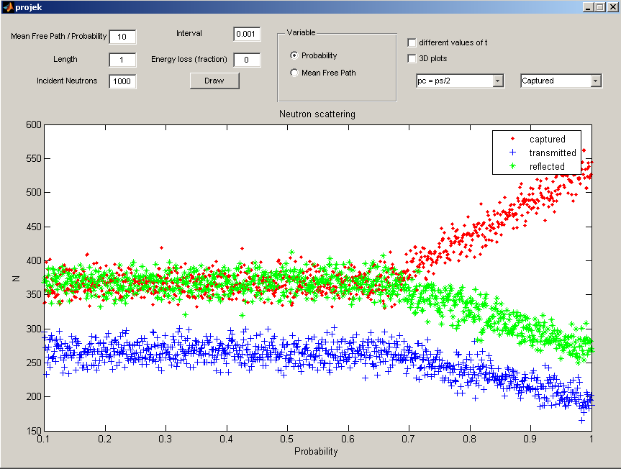 Figure 10

From the graphs we can see that as the mean free path increases the amount of transmitted neutrons is increased but only starts to increase noticeably when the mean free path is larger or equal to 1. The amount of captured neutrons starts to increase as gets around 0.7 and the transmitted and reflected neutrons decrease. We also notice that the amount of captured and reflected neutrons is almost the same for smaller than 0.7. If we compare Figure 1-5 and Figure 6-10 we notice when the amount of incident neutrons increase that the deviations of the amount of transmitted, captured and reflected neutrons gets smaller and thus giving more accurate results.

To further analyze the relation between the variables we now consider a plate that has thickness 2, capture probability equal to scatter probability and a constant mean free path 0.05. Again consult Appendix B for how the program works.

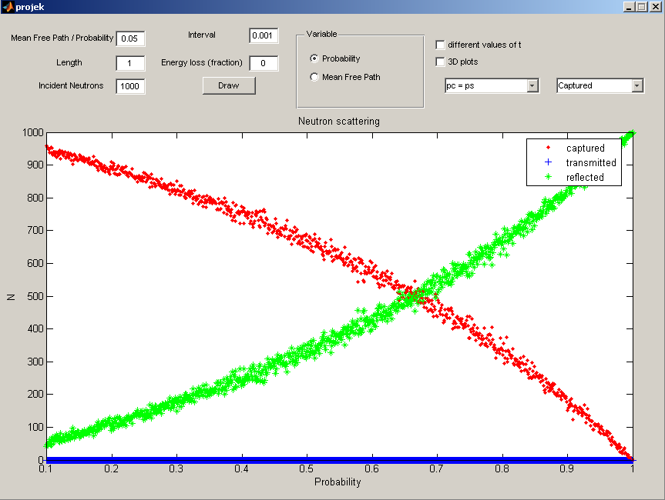
Figure 11

The amount of transmitted neutrons is almost nonexistent again because the path length is smaller than 1. If we compare Figure 11 with Figure 7 we see that for a different relation between and the results are very different. In the first case there was the almost the same amount of captured and reflected neutrons. Now that can take on bigger values the amount of reflected neutrons is initially very small but starts to increase as increases and decreases. The amount of captured neutrons decreases for the same case.

Again we consider equal to , but now change the thickness of the plate to 2 and the mean free path to 0.1.

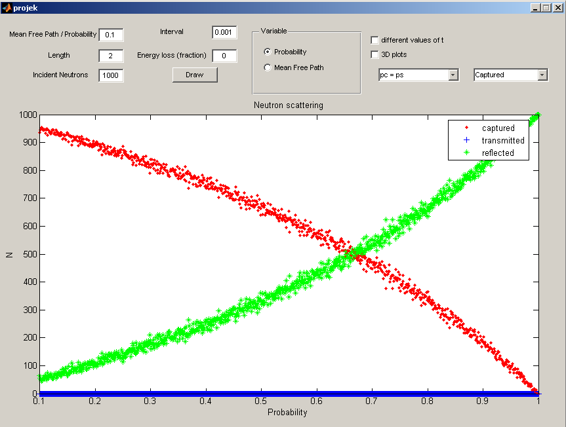
Figure 12

If we compare Figure 11 and Figure 12 we see that the same result was obtained. This is very interesting because we doubled the thickness and the mean free path length. This must mean that there is a relation between these two variables. Too see if this hold I will triple the values from Figure 11 in Figure 13.

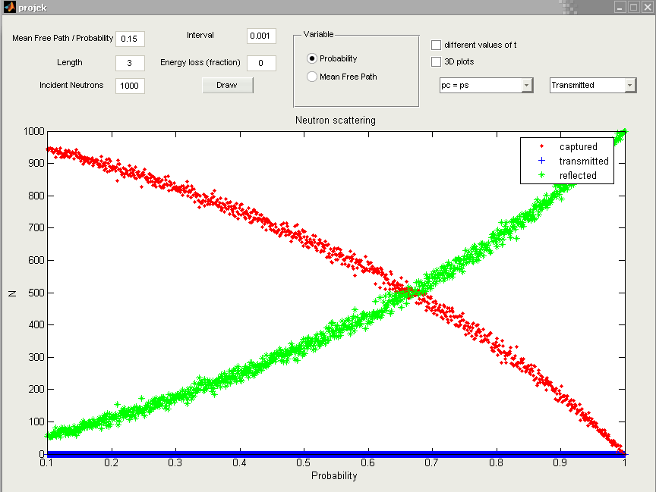
Figure 13

Again we see that the same results as before were obtained. We can therefore conclude that there exists a ratio between the two. If we take the values used the ratio is 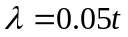.

In the next case we consider a fixed probability 0.5 and varying values of the mean free path for different thicknesses.
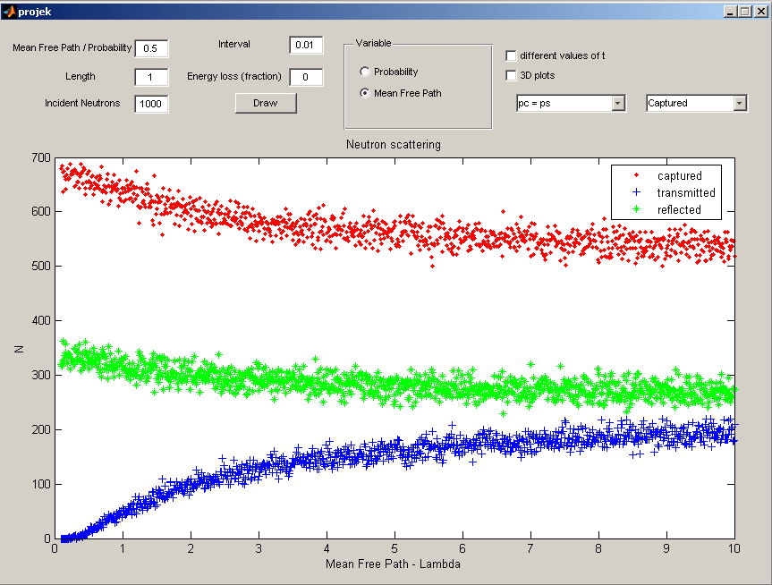
Figure 14
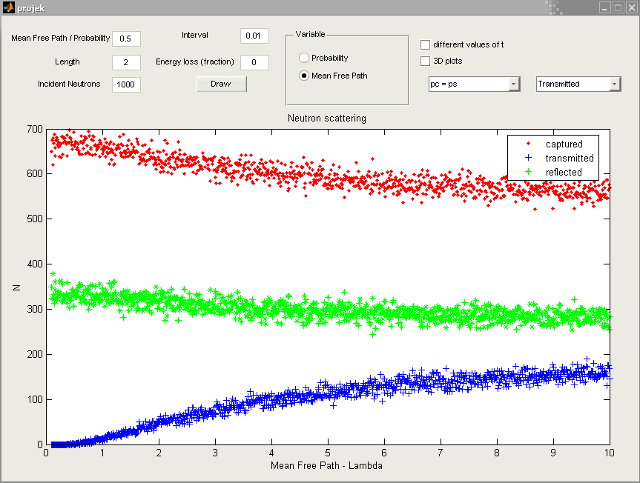
Figure 15
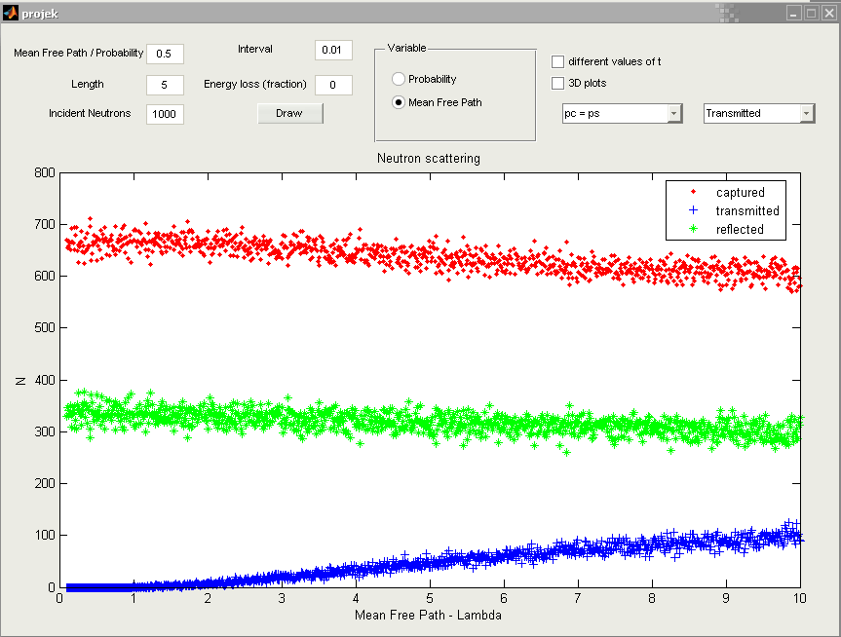
Figure 16
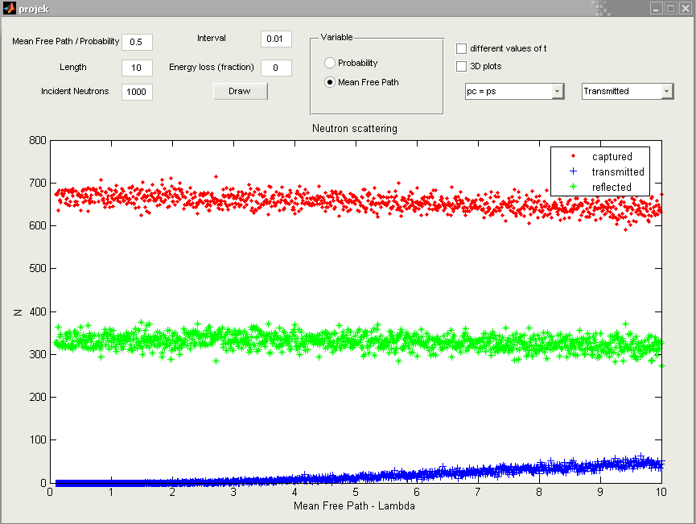
Figure 17

If we look at Figure 14-17 we see that when the thickness of the plate is increased the scattered neutrons take much longer to achieve the same values as when the thickness is small. Thus again showing that there is a relation between the thickness and mean free path.

Now we need to analyze some typical paths for the neutrons. First we look at captured neutrons.

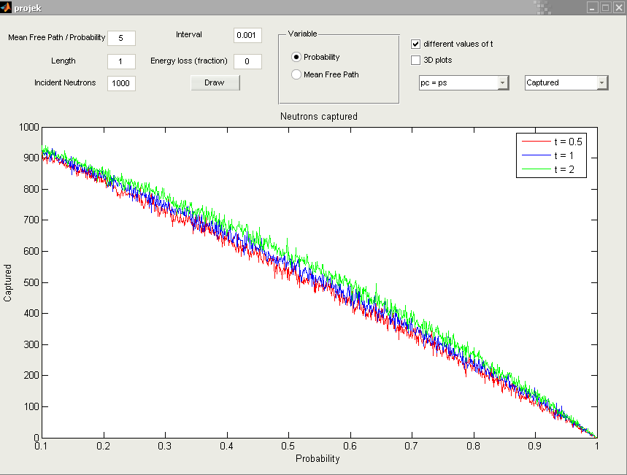
Figure 18
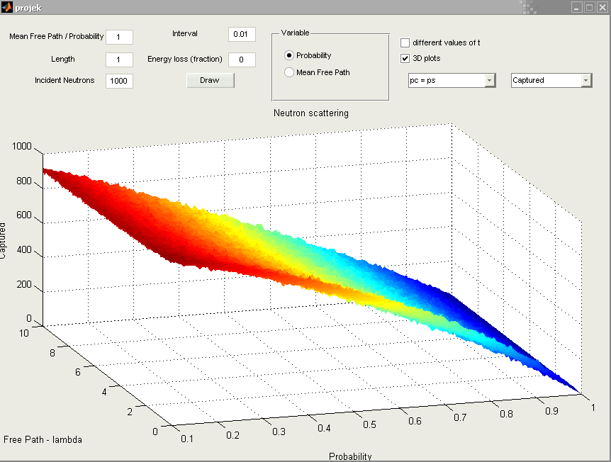
Figure 19

From Figure 18 we see that when the scattering probability increases the number of captured neutrons decreases and doesn’t depend on the thickness of the plate. If we now look at Figure 19 we also see that this relation doesn’t depend on the mean free path.

Next we analyze the transmitted neutrons.

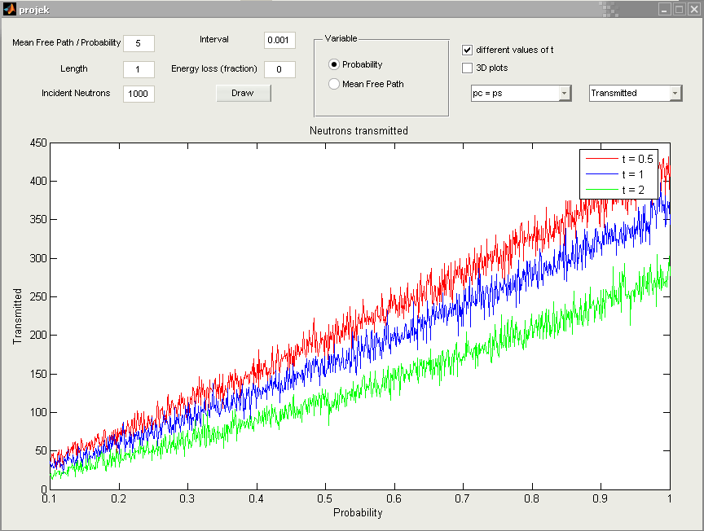
Figure 20
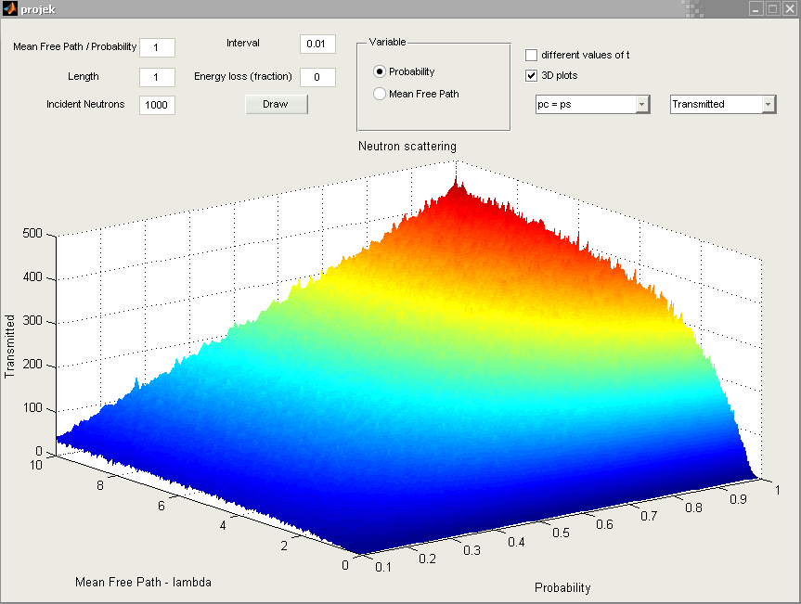
Figure 21
In Figure 20 we notice that when the plate is thicker the amount of transmitted neutrons is much lower at a given probability than when the plate is thinner. From Figure 21 we see that as the probability and the mean free path increases so does the amount of transmitted neutrons.

Last we analyze the reflected neutrons.

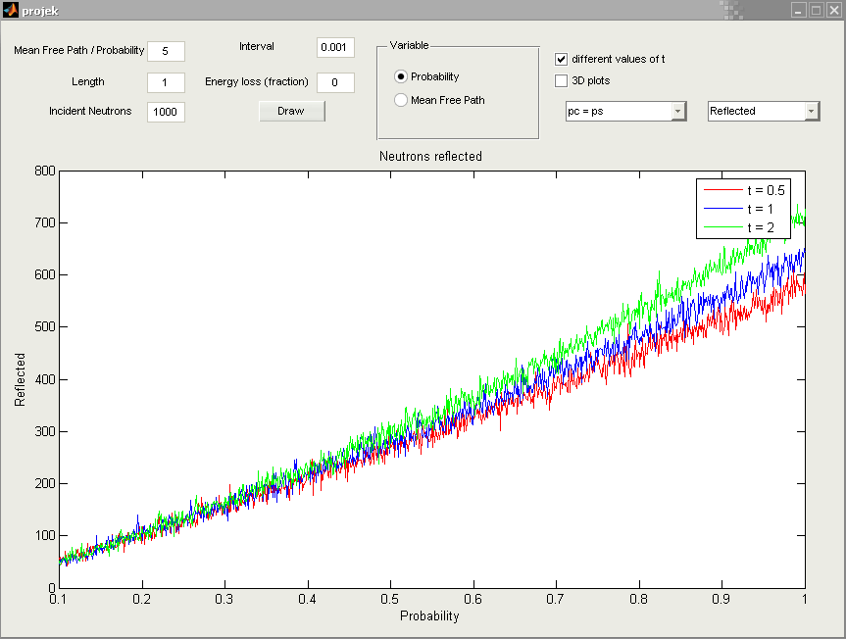
Figure 22
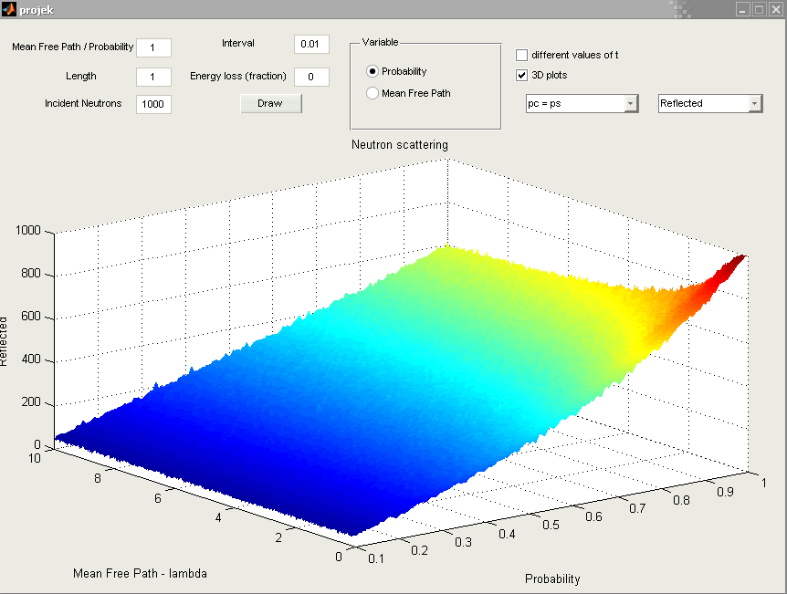
Figure 23

Figure 22 shows that as the scattering probability increases the number of reflected neutrons increases and does marginally more so when the thickness of the plate is bigger. From Figure 23 we see that the amount of reflected neutrons increases when the scattering probability increases and is only influenced by the mean free path when it’s very small.

So far we have only considered elastic scattering. Now we need to analyze the data when a fraction of the neutron’s energy is lost. We will consider 1000 incident neutrons, thickness 1, half of the scatter probability and different values for the mean free path. The fractions of energy lost we analyze will be 0.05, 0.1 and 0.5. First we consider a loss of 0.05.
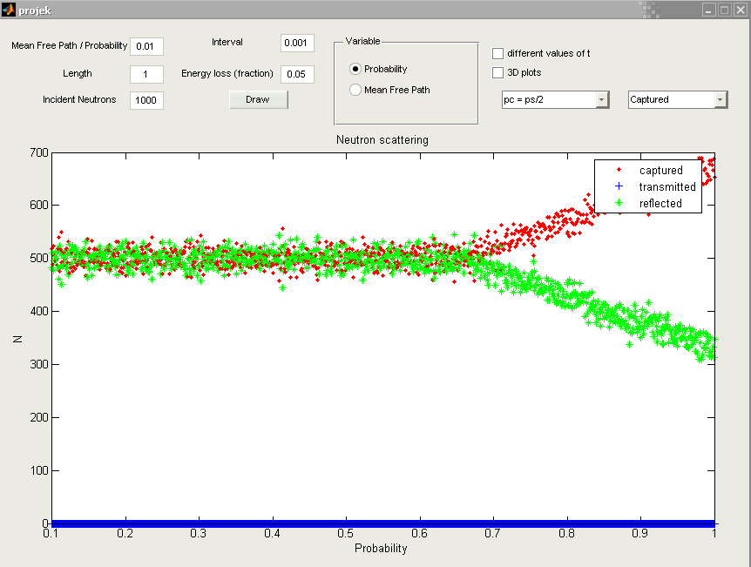
Figure 24
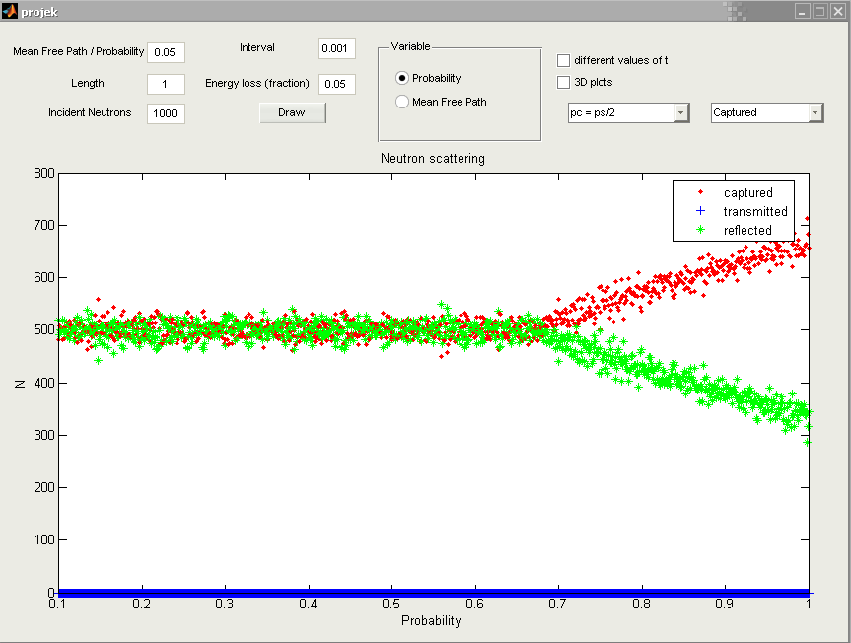
Figure 25
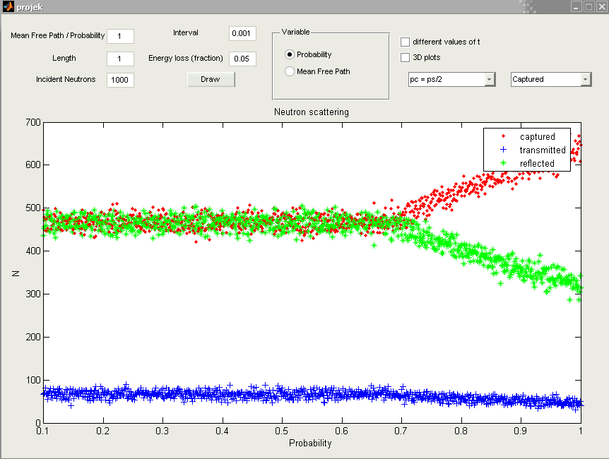
Figure 26

If we compare Figure 24-26 with Figure 6-8 we see that the amount of transmitted neutrons decreased when there was a loss of 0.05. I assume this is because the neutrons don’t have enough energy to be transmitted. To verify this we look at the following figures.
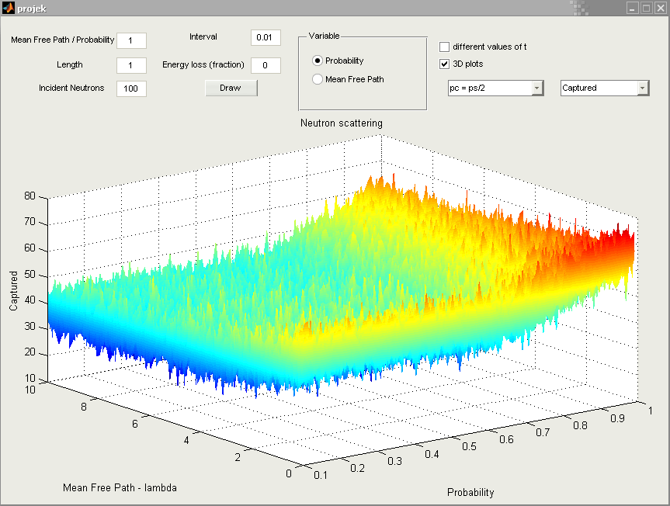
Figure 27
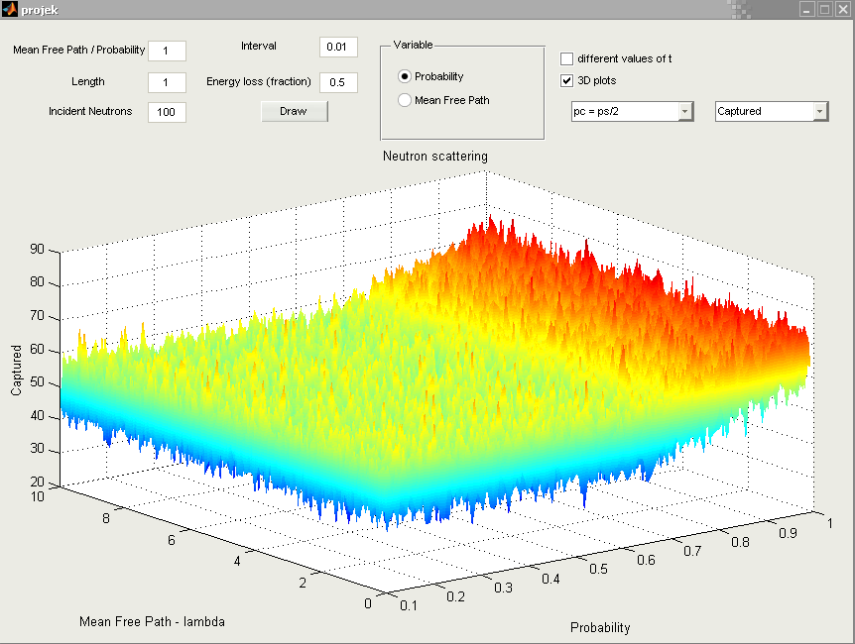
Figure 28
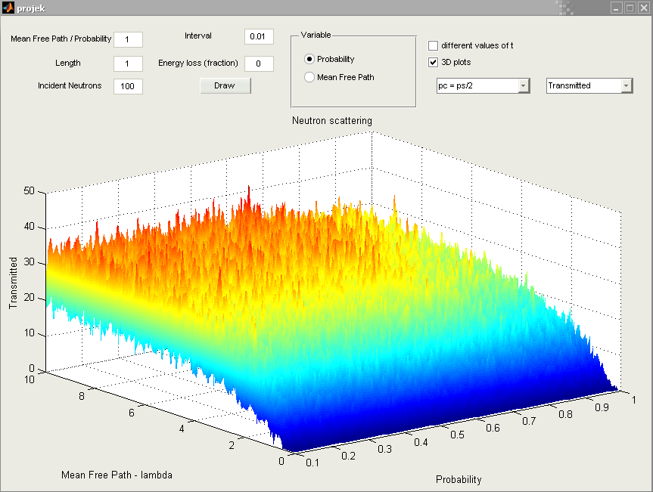
Figure 29
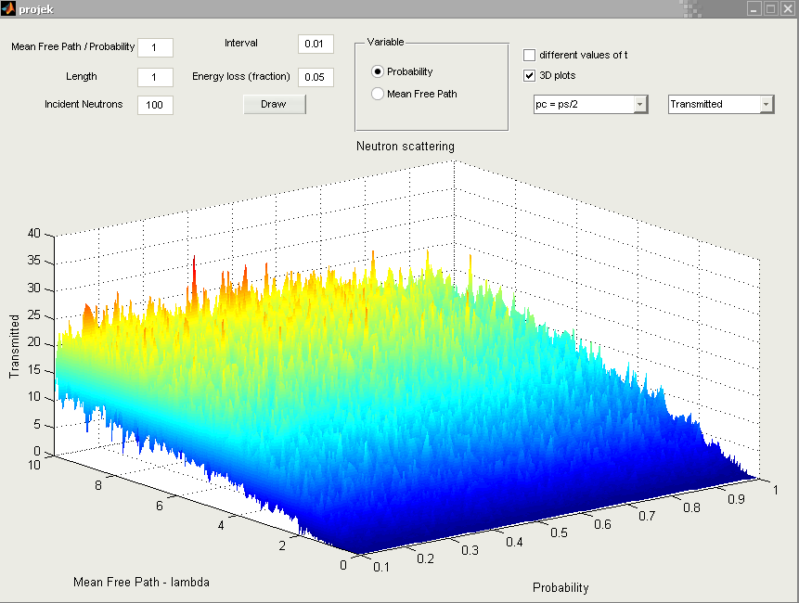
Figure 30
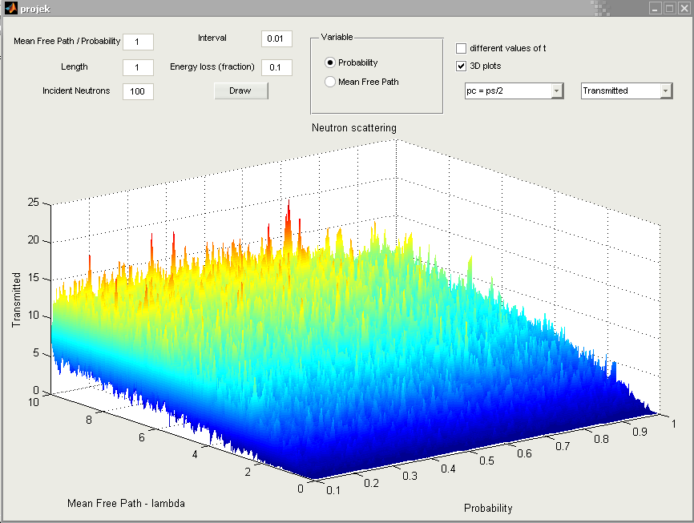
Figure 31
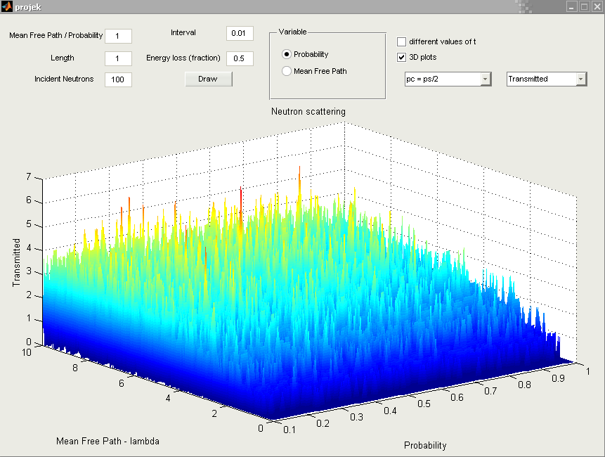
Figure 32
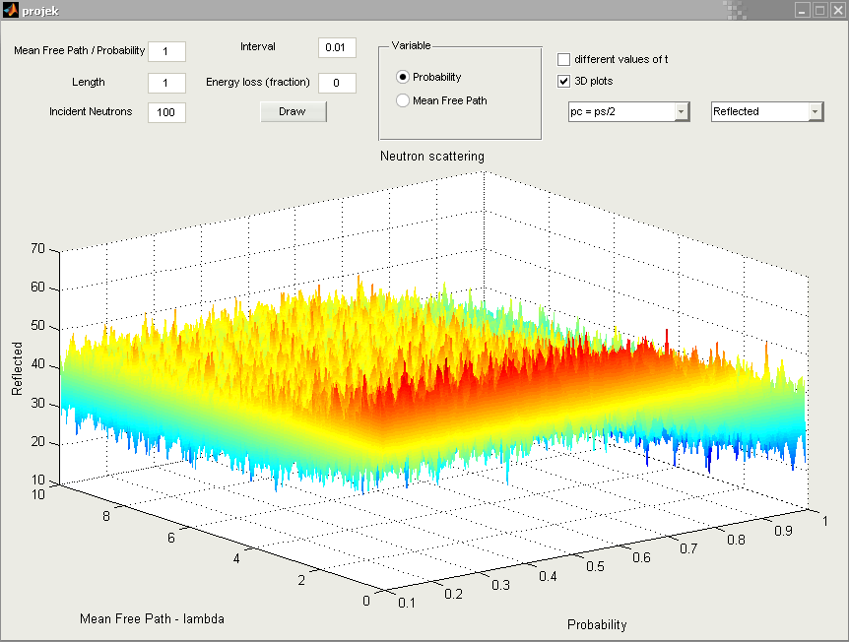
Figure 33
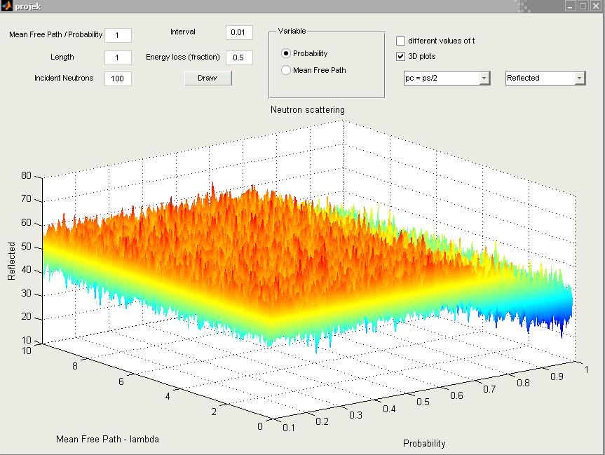
Figure 34
From Figure 27-28 we see that when the loss of energy increases the amount of captured neutrons slightly increases as well. From Figure 29-32 we see that the amount of transmitted neutrons decreases when the loss of energy increases. In Figure 33-34 again we see that the amount of reflected neutrons increases as the loss of energy increase. We can therefore conclude that when energy is lost fewer neutrons are transmitted and more is captured or reflected. Furthermore the inelastic scattering has the same characteristics as the elastic scatterings.

Lastly we plot the histogram for the path lengths between scattering events for different energy losses. We will use 0, 0.1 and 0.5. The code used to plot these bar charts is given in Appendix C.
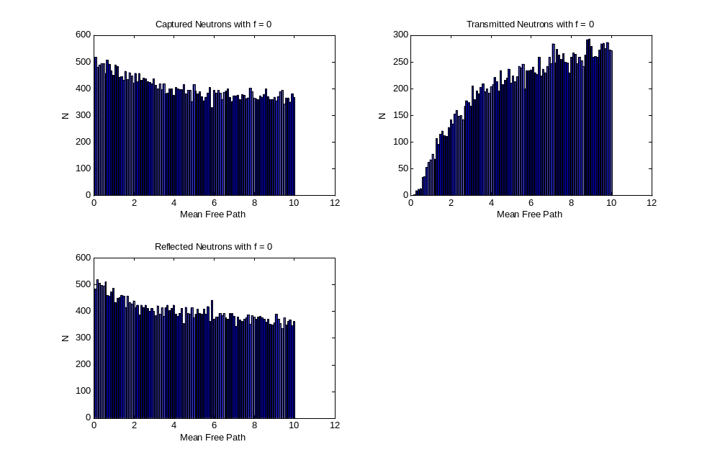
Figure 35
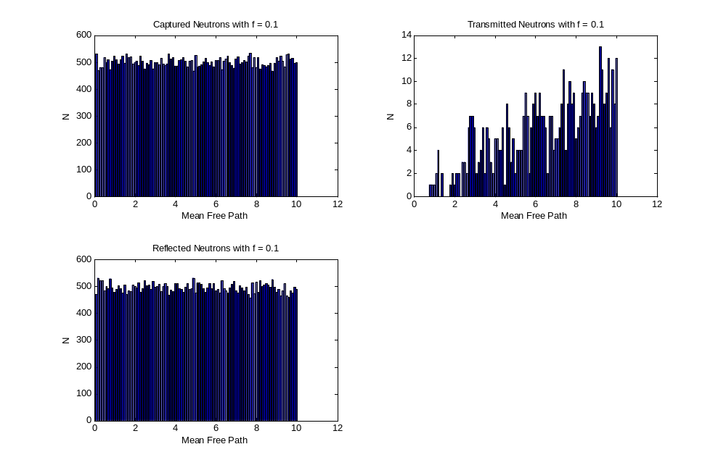
Figure 36
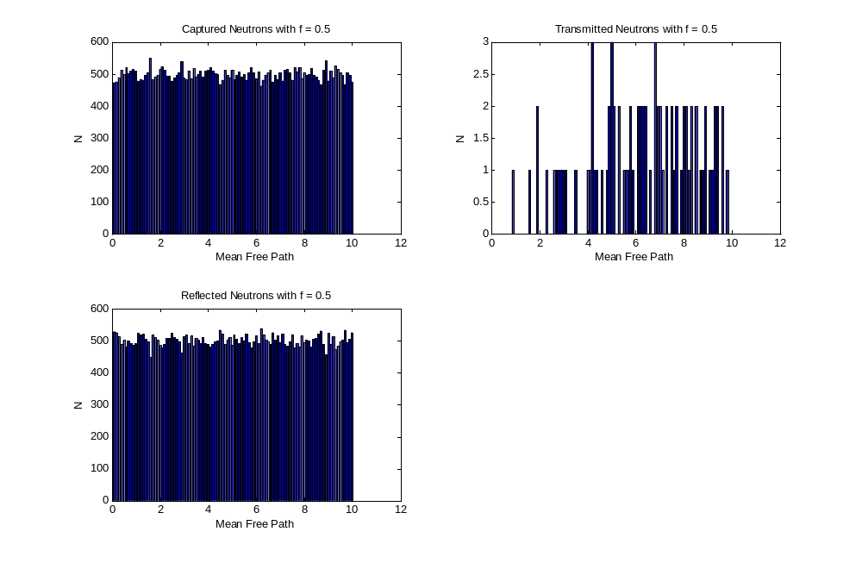
Figure 37

Again we see from the histograms how the amount of transmitted neutrons decreases as the energy loss increases.
Conclusion

Now we can formulate the relations between all the variables by using the data obtained in results. We noticed that there exists a relation between the mean free path and the thickness of the plate. When the scatter probability increases the amount of transmitted neutrons decreases and the amount of captured and reflected neutrons decreases. When the relation between the scatter and capture probability changes the way the reflected and transmitted neutrons increases is also different. If we look at the mean free path for different probabilities we see that there exists a relation. When the thickness of the plate is increased we notice that the scattered neutrons take much longer to achieve the same values. Last we saw that when the scattering is inelastic less neutrons get transmitted
Appendix A

This function computes the amount of transmitted, reflected and captured neutrons for given values.

function [captured,transmitted,reflected] = scatter(t,p,path,n,q,f)

ps = p;
if q == 1
pc = 1 - (ps / 2);
else
pc = ps;
end
E = path^2;
captured = 0;
transmitted = 0;
reflected = 0;
for i=1:n
busy = true;
while busy
neutron = rand;
if neutron >= pc
captured = captured +1;
E = E*(1-f);
path = sqrt(E);
busy = false;
else if neutron <= ps
ct = 1 - 2*rand;
l = -path*log(rand);
z = l*ct;
if z < 0
reflected = reflected +1;
E = E*(1-f);
path = sqrt(E);
busy = false;
end
if z > t
transmitted = transmitted +1;
E = E*(1-f);
path = sqrt(E);
busy = false;
end
end
end
end
end

Appendix B

This function handles all the necessary cases when the Draw button is pressed in the program.

% --- Executes on button press in but1.
function but1_Callback(hObject, eventdata, handles)
% hObject handle to but1 (see GCBO)
% eventdata reserved - to be defined in a future version of MATLAB
% handles structure with handles and user data (see GUIDATA)
clc;

con = str2num(get(handles.mfp,'String'));
t = str2num(get(handles.t,'String'));
n = str2num(get(handles.n,'String'));
k = str2num(get(handles.k,'String'));
f = str2num(get(handles.f,'String'));
choose = get(handles.choose, 'Value');
pop = get(handles.pop1, 'Value');
t_ch = get(handles.t_ch, 'Value');
td = get(handles.td, 'Value');

axes(handles.fig);
state = get(handles.prob_ch,'Value');
if (td == 1.0)
m = 1;
for h = 0.1:k:10
j = 1;
for i = 0.1:k:1
[a(m,j) b(m,j) c(m,j)] = scatter(t,i,h,n,choose,f);
j = j+1;
end
m = m+1;
end
[X,Y] = meshgrid(0.1:k:1,0.1:k:10);
switch pop
case 1
surf(X,Y,a);
zlabel('Captured');
case 2
surf(X,Y,b);
zlabel('Transmitted');
case 3
surf(X,Y,c);
zlabel('Reflected');
end
xlabel('Probability');
ylabel('Mean Free Path - lambda');
title('Neutron scattering');
shading interp;
rotate3d on;
elseif (t_ch == 1.0)
j = 1;
for i = 0.1:k:1
[a1(j) b1(j) c1(j)] = scatter(0.5,i,con,n,choose,f);
[a2(j) b2(j) c2(j)] = scatter(1,i,con,n,choose,f);
[a3(j) b3(j) c3(j)] = scatter(2,i,con,n,choose,f);
j = j+1;
end
switch pop
case 1
plot(0.1:k:1,a1,'r',0.1:k:1,a2,'b',0.1:k:1,a3,'g');
title('Neutrons captured');
ylabel('Captured');
case 2
plot(0.1:k:1,b1,'r',0.1:k:1,b2,'b',0.1:k:1,b3,'g');
title('Neutrons transmitted');
ylabel('Transmitted');
case 3
plot(0.1:k:1,c1,'r',0.1:k:1,c2,'b',0.1:k:1,c3,'g');
title('Neutrons reflected');
ylabel('Reflected');
end
xlabel('Probability');
legend('t = 0.5','t = 1','t = 2');
else
if (state == 1.0)

for i = 0.1:k:1
[a b c] = scatter(t,i,con,n,choose,f);
plot(i,a,'r.',i,b,'b+',i,c,'g*');
hold on;
end
xlabel('Probability');
legend('captured','transmitted','reflected');
else
for i = 0.1:k:10
[a b c] = scatter(t,con,i,n,choose,f);
plot(i,a,'r.',i,b,'b+',i,c,'g*');
hold on;
end
xlabel('Mean Free Path - Lambda');
legend('captured','transmitted','reflected');
end
title('Neutron scattering');
ylabel('N');
end

hold off;

Appendix C

This function draws the bar chart for losses energy.

function barscatter(f);
j=0;
for i=0.1:0.1:10
j = j+1;
[a(j) b(j) c(j)] = scatter(1,0.5,i,1000,1,f);
bins(j) = i
end
figure;

subplot(2,2,1);
bar(bins,a);
title(['Captured Neutrons with f = ',num2str(f)]);
xlabel('Mean Free Path');
ylabel('N');

subplot(2,2,2);
bar(bins,b);
title(['Transmitted Neutrons with f = ',num2str(f)]);
xlabel('Mean Free Path');
ylabel('N');

subplot(2,2,3);
bar(bins,c);
title(['Reflected Neutrons with f = ',num2str(f)]);
xlabel('Mean Free Path');
ylabel('N');
References

Class notes – see photo copied handouts

